SpendWise: A Simple Backend Learning Project
Ideation Phase
Define the Problem Statements

Date | 13 February 2026
Team ID | SWTID-2026-6869
Project Name | SpendWise
Maximum Marks | 2 Marks

Customer Problem Statement Template:
A customer problem statement helps understand the user’s point of view while learning from a product. In the SpendWise project, it focuses on the needs of beginner backend students who want to learn Node.js, Express, MongoDB, and JWT in a simple way. It helps identify problems like confusion with complex projects and difficulty connecting concepts, so the solution stays clear, useful, and easy to learn.

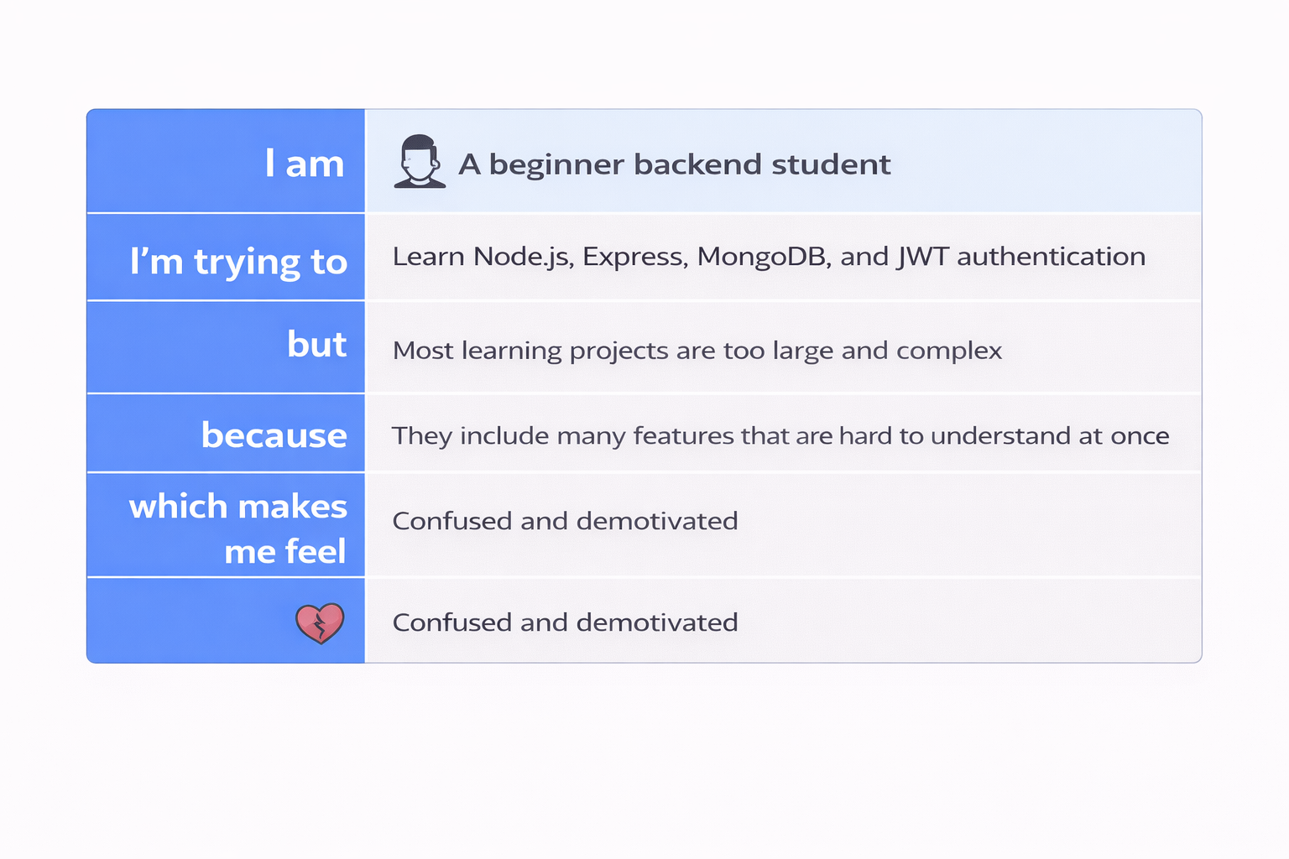

Example:
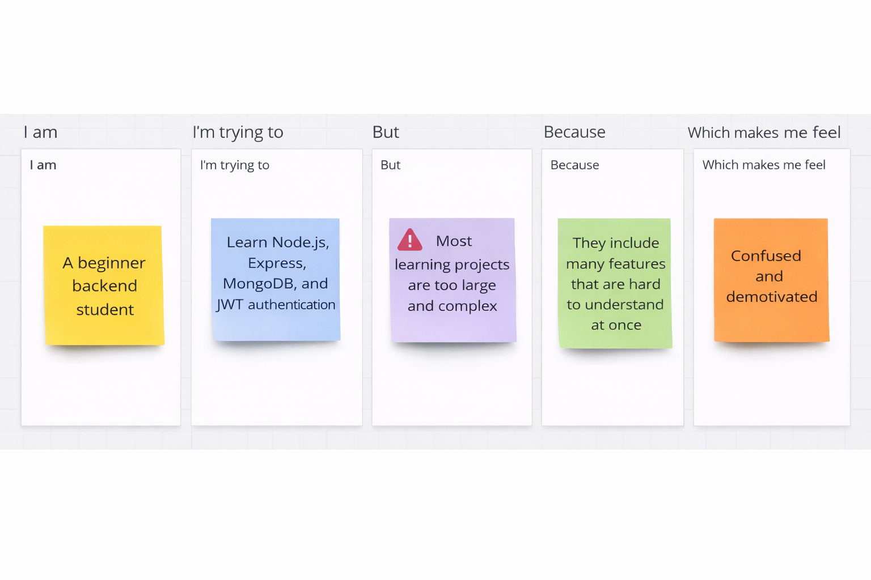
Problem Statement (PS) | I am (Customer) | I’m trying to | But | Because | Which makes me feel
PS-1 | A beginner backend student | Learn Node.js, Express, MongoDB, and JWT authentication | Most learning projects are too large and complex | They include many features that are hard to understand at once | Confused and demotivated
PS-2 | A college student | Build a simple backend project for practice and submission | I don’t find a clear example focused only on CRUD and authentication | Tutorials often jump to advanced topics without explaining basics | Unsure about my understanding
PS-3 | A beginner developer | Connect JWT authentication with MongoDB and APIs | I keep getting errors in tokens or database connection | The flow between login, token, and protected routes is not clear | Frustrated and stuck
PS-4 | A student preparing for viva or interviews | Explain CRUD operations and JWT authentication with a project | I don’t have a simple end-to-end backend example | Most available projects are either too basic or too advanced | Nervous and underprepared

